Updating SC Ladder to support Beacon Muting:
General Overview:
The Simple Connect light beacons/towers are equipped with an audible alarm that will sound in the event of alarms or errors with the system. It is often desirable at times to silence or mute the audible alarm while issues with the system are being resolved. This is normally done by enabling PSEUDO INPUT# 87200. However, this functionality was only introduced in early 2023 with Simple Connect ladder version#1.2.3. The value contained in register M435 is the Simple Connect ladder version. If M435 is equal to 123 or greater the system has the muting functionality already installed and the following steps do NOT need to be done. If the value of M435 is 122 of less, the following applies.

The following will allow you to update a customer’s ladder with an earlier version of Simple Connect ladder and return it to the customer with the needed “USER” section ladder changes made to allow muting of the beacon(s) via the 87200 PSEUDO input. In another article, customers are instructed to send the following two files to TechSupport@motoman.com:
- CIOPRG.LST
- PSEDUOIN.DAT

Upon receiving the above files, a Yaskawa member needs to use the “CIO Update” tool to implement an attached ladder change that will allow muting to occur with the transition of 87200 and cause a message indicating “BEACON MUTED (PSEDU IN#87200 = ON” when 87200=ON.

CIOPRG.LST Ladder Update:
- Launch the “CIO Update” tool & choose “Find Concurrent IO File” then browse to the customer supplier CIOPRG.LST. Once selected, the left-side of the screen will populate with the user supplied ladder
- Press the “Import Another Mod File” and select a downloaded copy of the attached “change file”. Once selected, this will populate the right-side of the screen with the changes about to be forced into the customer’s ladder.
- Press the “Make These Changes” which will implement the desired updates to the customer’s ladder

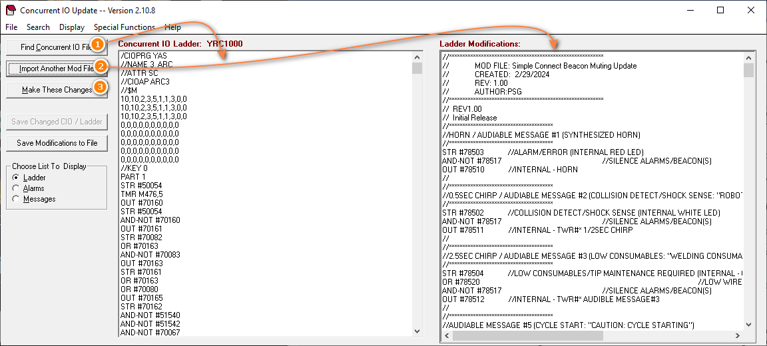
While the changes are being implemented, a progress bar will appear on the screen. Ideally when the changes are completed, the progress bar will close and the updated file will get saved replacing the original file. If an alarm box appears, please share the source files from the customer with PSG for additional review!

PSEUDOIN.DAT File Modification:
To add the necessary label to PSEUDO IN# 87200, the “PSEUDOIN.DAT” needs to be manually modified. To do that simply open the DAT file in a text editor and enter the text “BEACON(S) MUTE” on the 11th line before the first comma. Once completed save the file.
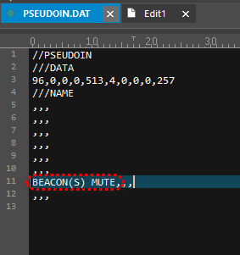

Returning files to customer:
Email the modified CIOPRG.LST and PSEUDOIN.DAT file back to the customer and tell them to load the two files with “Management Mode” security level. Once loaded the customer should be able to utilize the muting function by toggling the 87200 Pseudo input:

- In TEACH mode & “Management” level security chooose “IN/OUT”
- Choose “PSEUDO INPUT SIG”
- Use to the PAGE key to highlight “87200” and press “INTERLOCK”+”SELECT”. Doing so will toggle between muted and unmuted.
- Notice the message on the bottom of the screen indicating that the alarm was intensionally muted
